**Assignment 6**

**Task 1. Create the following segment in terms of Purchase**

**- Affordable ( if< 10)**

**- Expensive (if >10)**

->After Loading data into Power BI.Navigate to Table **Purchase** in Data View and click on New column under Table tools.Now use the following DAX formula for segmenting

**Purchase Segment= IF (Purchase[‘Price’]<10,”Affordable”, “Expensive”)**

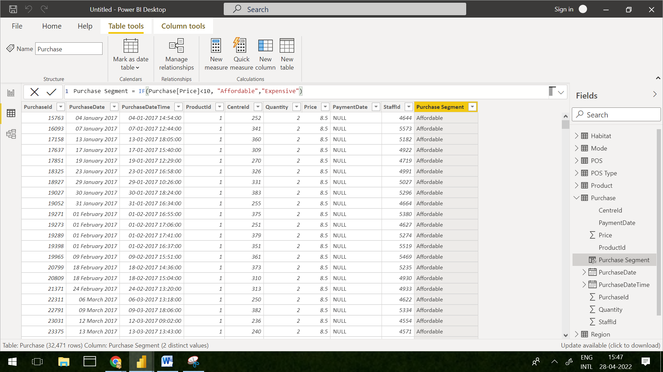

**Task 2. Need a report on the quantities available on the basis of Animal**

**1. Affordable**

**2. Expensive**

In Report View, Select Clustered Bar Chart and Select **column Quantity, Purchase Segment** from **Purchase Table** and **column Animal** from **Product Table.**

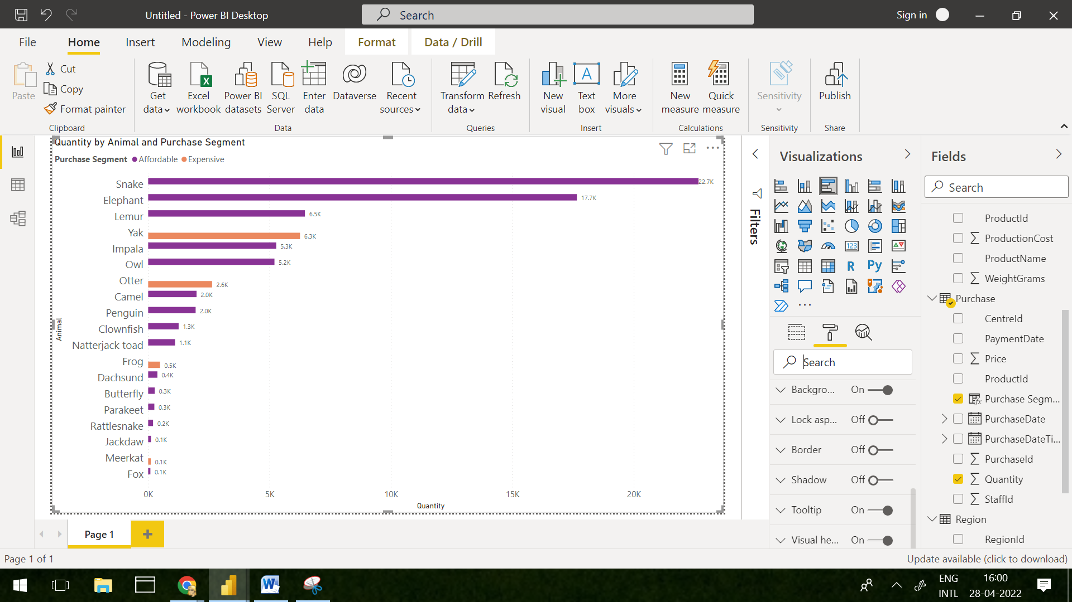

**Task 3. Need to know how many animals do not belong to Air, Water & land**

First, we need to create new measure in report view by selecting **NEW MEASURE** option in Home menu.Using following DAX formulas, we can get required output

**NotAir = CALCULATE(COUNT('Product'[Animal]),FILTER(RELATEDTABLE(Habitat),Habitat[EnvironmentId] IN {1,3}))**

**NotWater = CALCULATE(COUNT('Product'[Animal]),FILTER(RELATEDTABLE(Habitat),Habitat[EnvironmentId] IN {1,2}))**

**NotLand = CALCULATE(COUNT('Product'[Animal]),FILTER(RELATEDTABLE(Habitat),Habitat[EnvironmentId] IN {2,3}))**

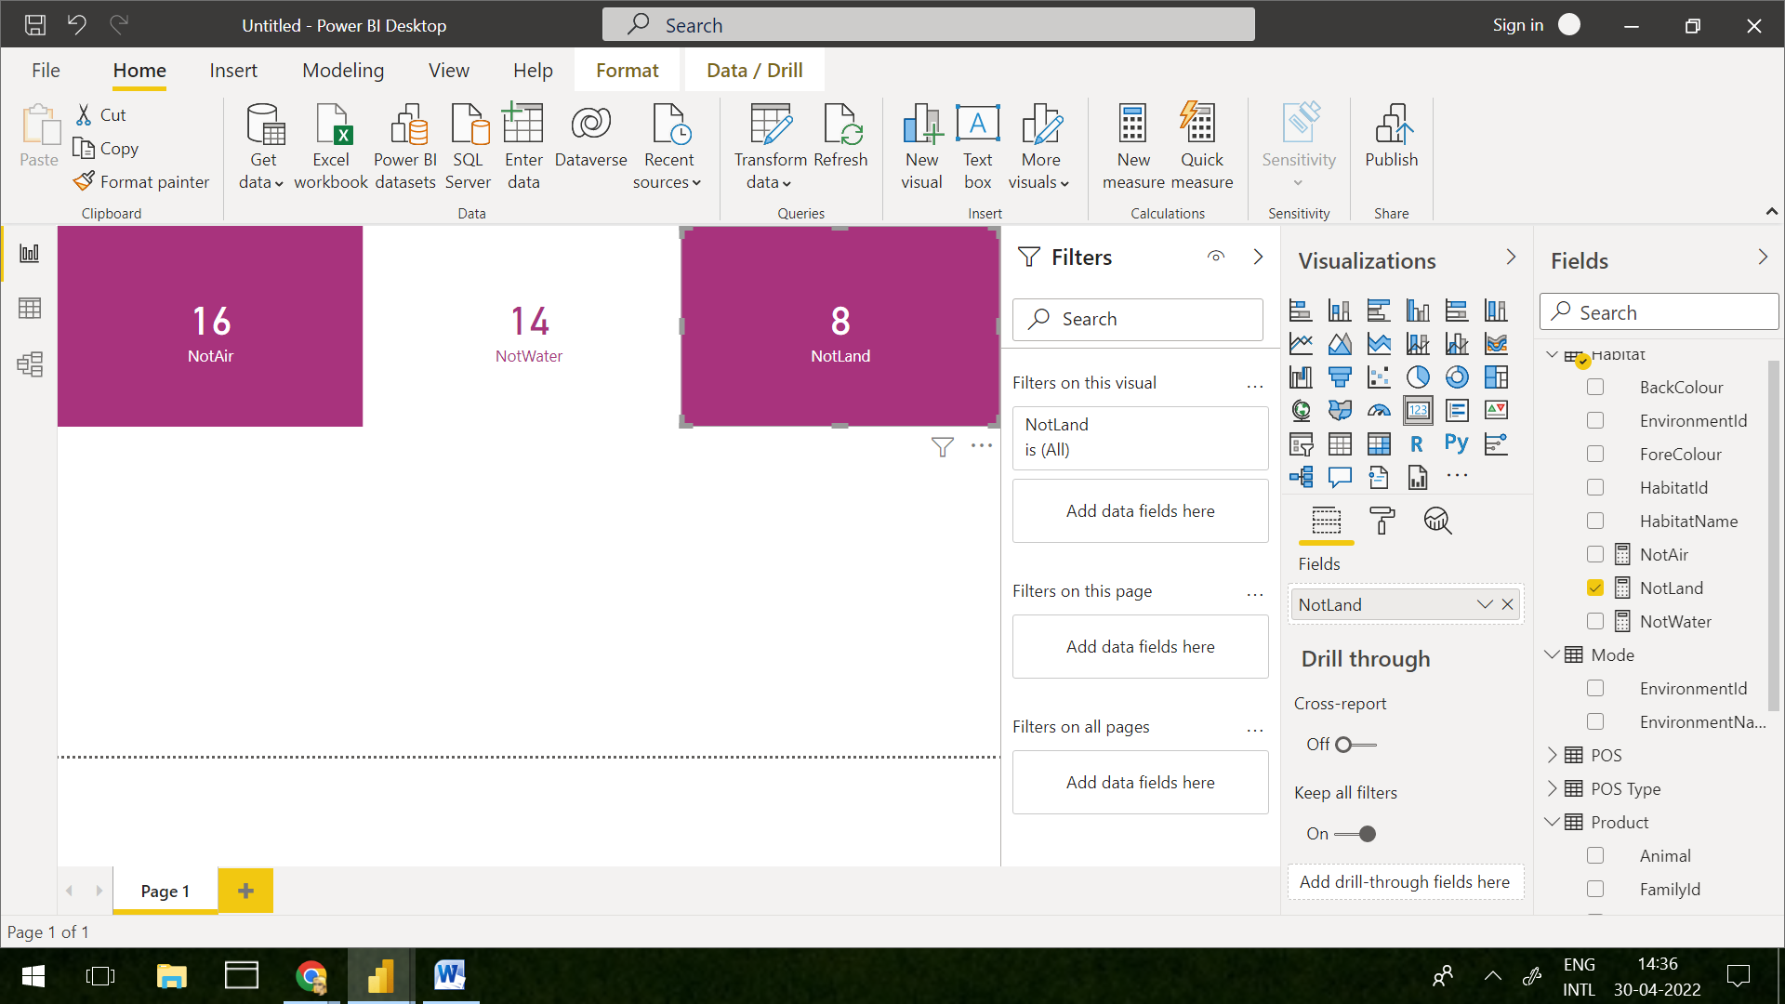

**Task 4. Create a segment on the basis of Species by the referring Animals and create a column in the required table. (hint – Product Table)**

In Data view of Product Table, on selecting **NEW COLUMN** under HOME and upon using the following formula, we can get the desired output.

**SpeciesSegment = if('Product'[FamilyId]= RELATED(Species[FamilyId]), RELATED(Species[FamilyName]),BLANK())**

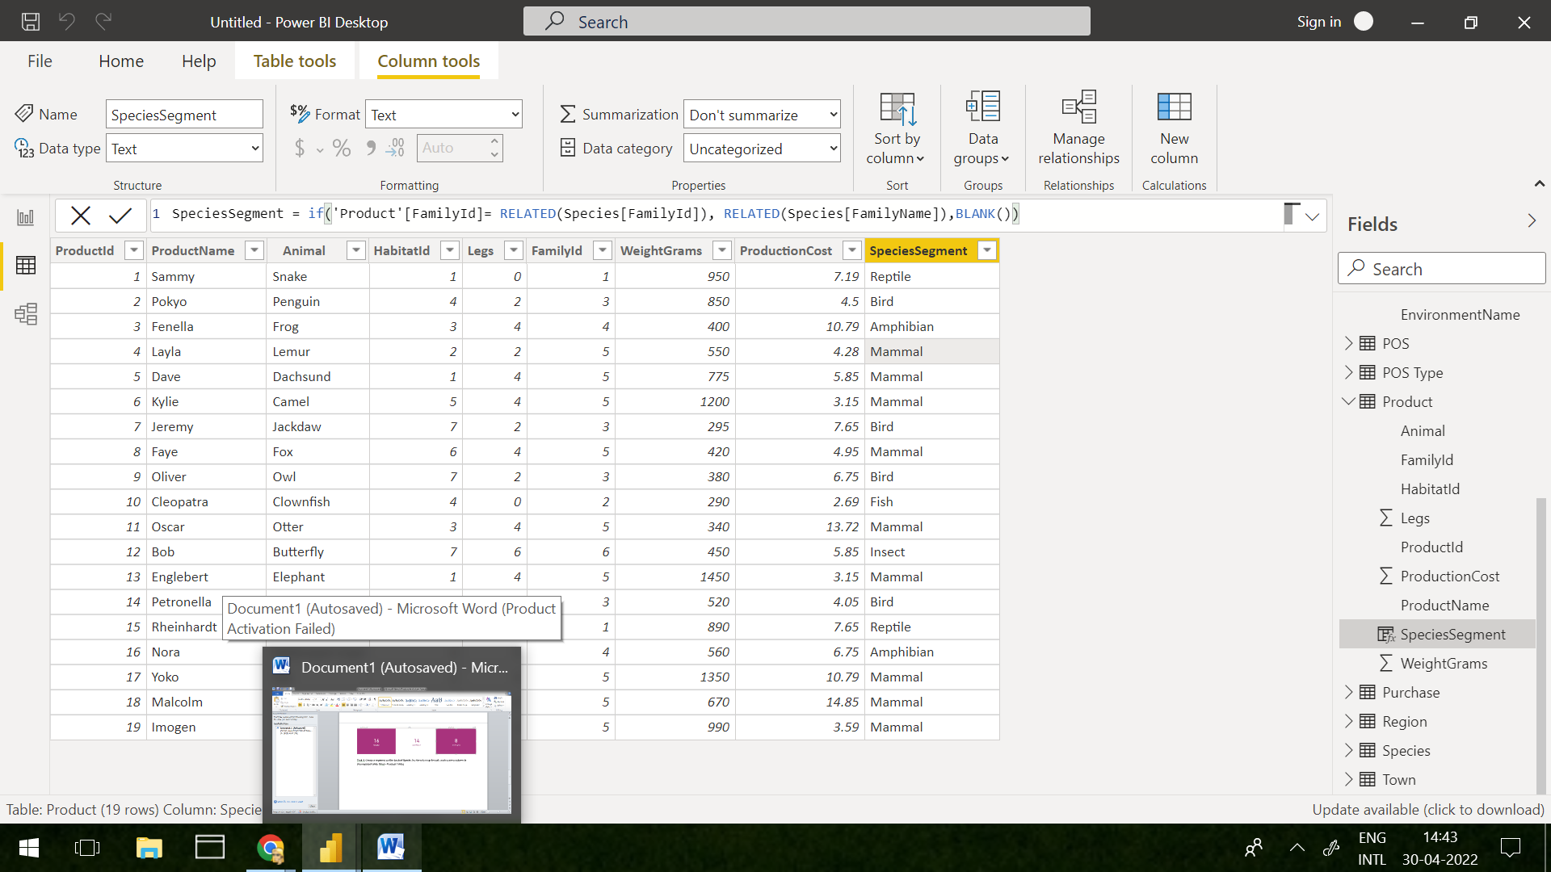

**Task 5.** **Need to segment the towns on the basis of region.**

In Data view of Town Table, on selecting **NEW COLUMN** under HOME and upon using the following formula, we can get the desired output.

**RegionSegment = IF(Town[RegionId]=RELATED(Region[RegionId]),RELATED(Region[RegionName]),BLANK() )**

